**PRACTICAL REPORT**

**ON**

**Microservices Architecture**

**SUBMITTED BY**

**Suryakant Pandurang Chavan**

**ROLL NO: MM21002**

**SUBMITTED TO**

**Mrs. Sandhya Pandey**

**M.Sc. (INFORMATION TECHNOLOGY) SEM-II 2021 - 2022**



**CONDUCTED at**

**The South Indian Association's  
 The S.I.A. College of Higher Education**

Affiliated to University of Mumbai

Accredited ‘B+’ Grade Dombivli East, MUMBAI - 421203

**INDEX**

|  |  |
| --- | --- |
| **Sr. No.** | **Aim** |
| Practical No. **1** | Building APT.NET Core MVC Application. |
| Practical No. **2** | Building ASP.NET Core REST API. Software requirement: |
| Practical No. **3** | Working with Docker, Docker Commands, Docker Images and Containers |
| Practical No. **4** | Working with Circle CI for continuous integration |

**Practical No. - 1**

**Building APT.NET Core MVC Application.**

1. Start visual studio 2019
2. Click on create a new project

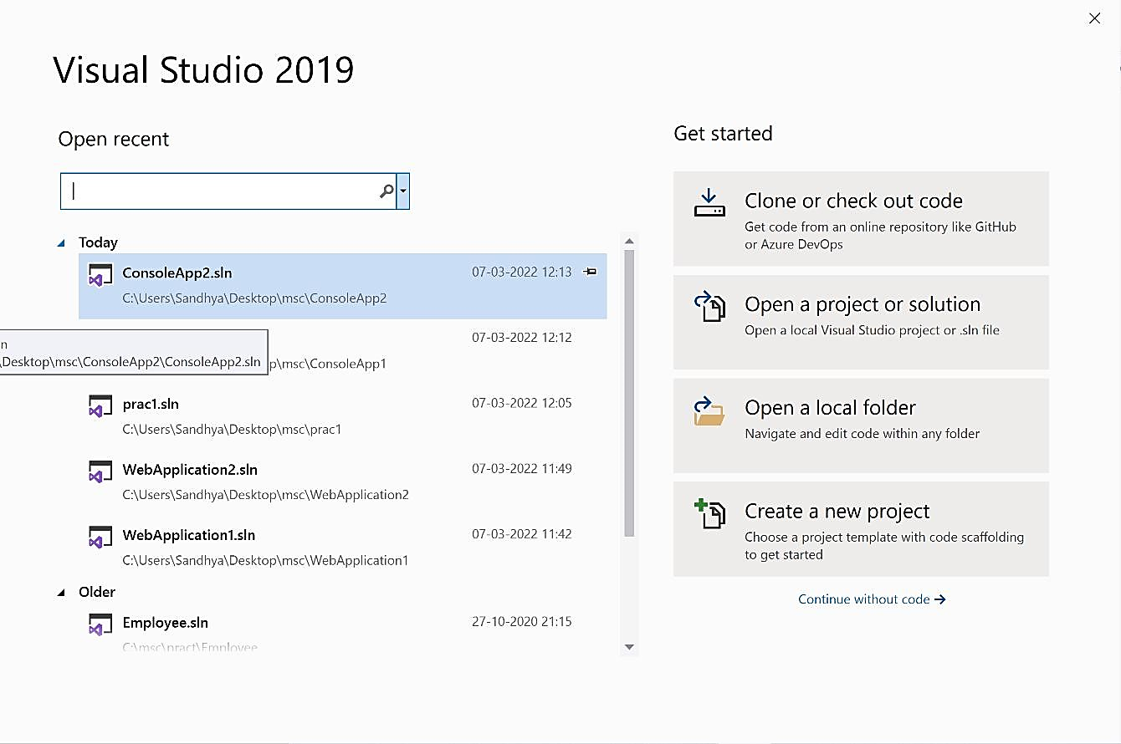

1. Click on ASP.NET Core Web Application and click Next

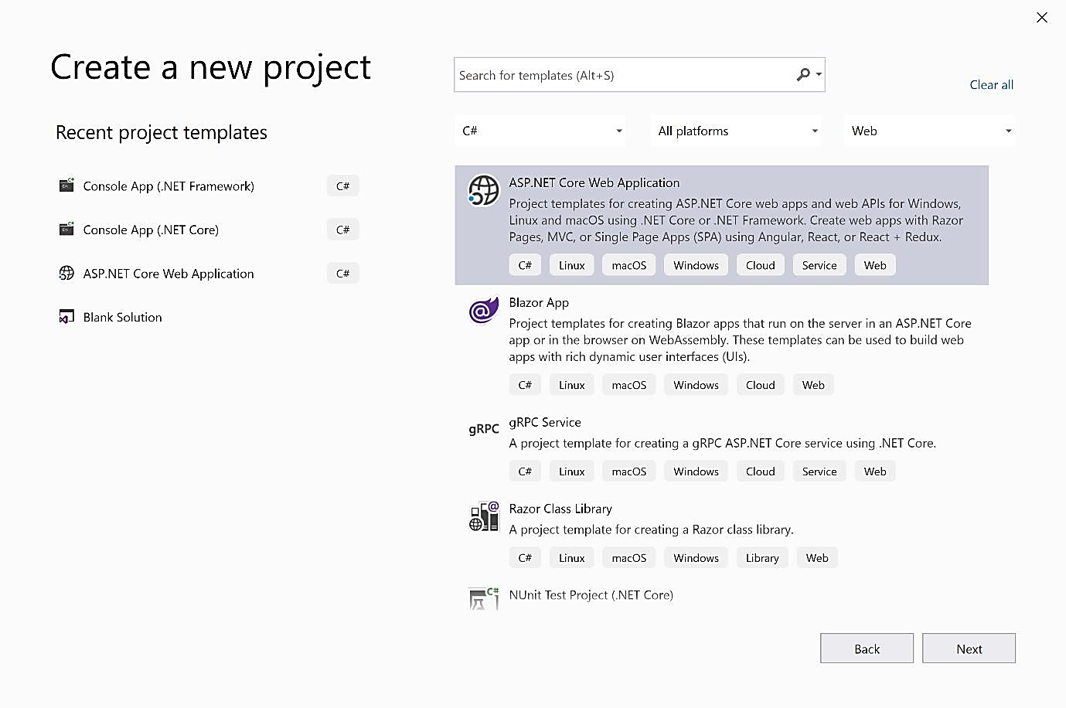

1. Set Project name and click on create

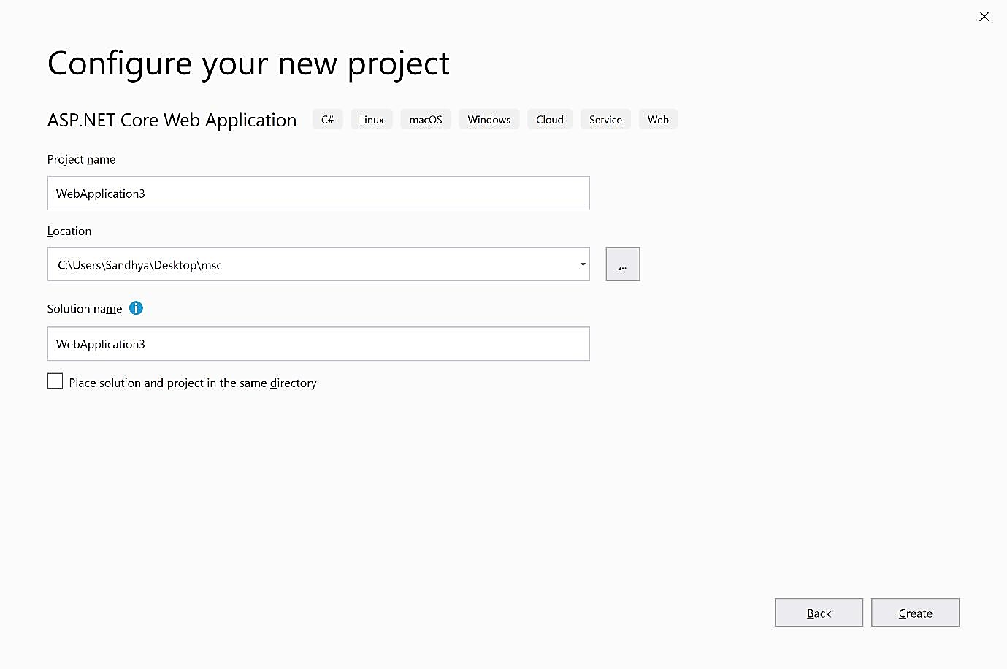

1. Click on Web Application (Model-View-Controller ) and click on create

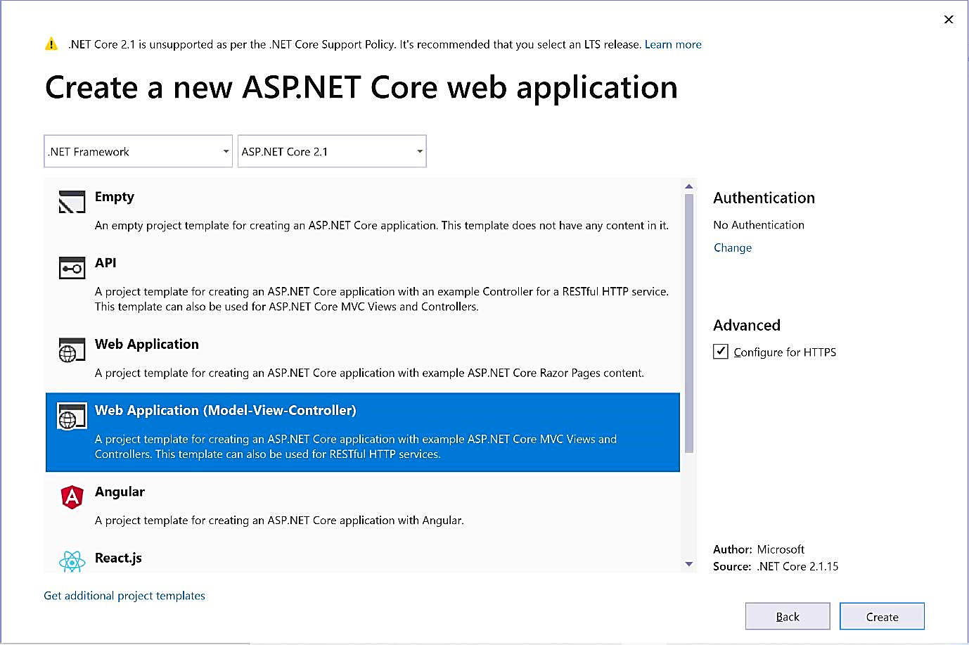

1. Click on Views→Home→Index.cshtml
2. Edit the file and enter the string Hello World….

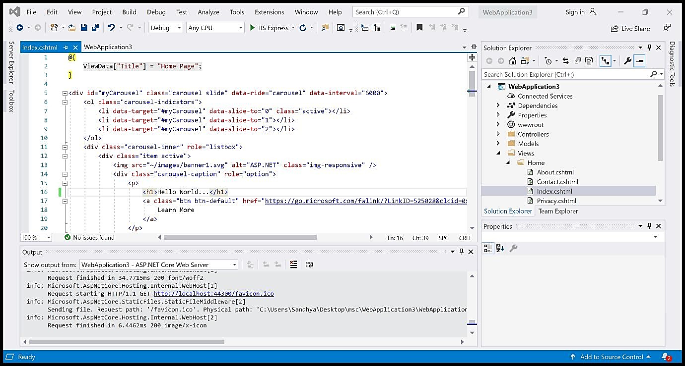

1. Run the program by clicking on IIS Express

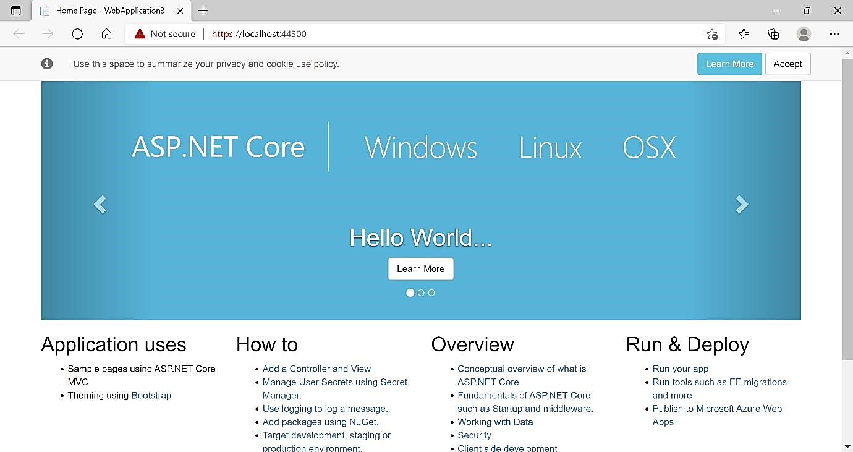

**Practical No. – 2**

**Building ASP.NET Core REST API.Software requirement:**

1. **Download and install**

To start building .NET apps you just need to download and install the .NET SDK (Software Development Kit version 3.0 above).

Link:

<https://dotnet.microsoft.com/learn/dotnet/hello-world-tutorial/install>

1. **Check everything installed correctly**

Once you've installed, open a new command prompt and run the following command:

Command prompt > dotnet

**Create your web API**

1. **Open two command prompts** Command prompt 1:

**Command:** dotnet new webapi -o **Glossary output:**

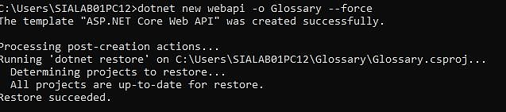

**Command:**

cd Glossary dotnet run

**Output:**

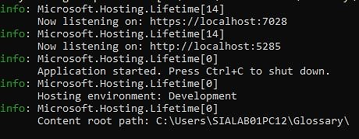

1. **Command Prompt 2:** (try running ready made weatherforecast class for testing) **Command:**

curl --insecure https://localhost:7071/weatherforecast

**Output:**

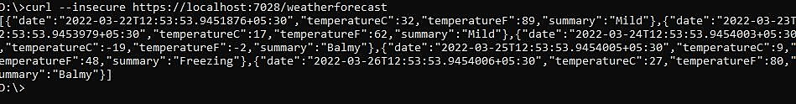

1. **Now Change the content:**

**To get started, remove the WeatherForecast.cs file from the root of the project and the WeatherForecastController.cs file from the Controllers folder.**

**Add Following two files**

1. **D:\Glossary\GlossaryItem.cs (type it in notepad and save as all files)**

//GlossaryItem.cs namespace Glossary

{

public class GlossaryItem

{

public string Term { get; set; } public string Definition { get; set; }

}

}

1. **D:\Glossary\Controllers\ GlossaryController.cs (type it in notepad and save as all files)**

//Controllers/GlossaryControl er.cs using System;

using System.Collections.Generic; using Microsoft.AspNetCore.Mvc; using System.IO;

namespace Glossary.Controllers

{

[ApiController]

[Route("api/[controller]")]

public class GlossaryController: ControllerBase

{

private static List<GlossaryItem> Glossary = new List<GlossaryItem>

{new GlossaryItem

{

Term= "HTML",

Definition = "Hypertext Markup Language"

},

new GlossaryItem

{

Term= "MVC",

Definition = "Model View Controller"

},

new GlossaryItem

{

Term= "OpenID",

Definition = "An open standard for authentication"

}

};

[HttpGet] public ActionResult<List<GlossaryItem>> Get()

{ return Ok(Glossary);

}

[HttpGet] [Route("{term}")] public ActionResult<GlossaryItem> Get(string term)

{

var glossaryItem = Glossary.Find(item => item.Term.Equals(term, StringComparison.InvariantCultureIgnoreCase));

if (glossaryItem == null)

{ return NotFound();

} else

{

return Ok(glossaryItem);

}

}

[HttpPost] public ActionResult Post(GlossaryItem glossaryItem)

{

var existingGlossaryItem = Glossary.Find(item => item.Term.Equals(glossaryItem.Term, StringComparison.InvariantCultureIgnoreCase));

if (existingGlossaryItem != null)

{

return Conflict("Cannot create the term because it already exists.");

}

else

{

Glossary.Add(glossaryItem); var resourceUrl = Path.Combine(Request.Path.ToString(), Uri.EscapeUriString(glossaryItem.Term)); return Created(resourceUrl, glossaryItem);

}

}

[HttpPut] public ActionResult Put(GlossaryItem glossaryItem)

{

var existingGlossaryItem = Glossary.Find(item => item.Term.Equals(glossaryItem.Term, StringComparison.InvariantCultureIgnoreCase));

if (existingGlossaryItem == null)

{

return BadRequest("Cannot update a nont existing term.");

}

else

{

existingGlossaryItem.Definition = glossaryItem.Definition; return Ok();

}

}

[HttpDelete] [Route("{term}")] public ActionResult Delete(string term)

{

var glossaryItem = Glossary.Find(item => item.Term.Equals(term, StringComparison.InvariantCultureIgnoreCase));

if (glossaryItem == null)

{ return NotFound();

}

else

{ Glossary.Remove(glossaryItem); return NoContent();

}

}

}

}

**Output:**

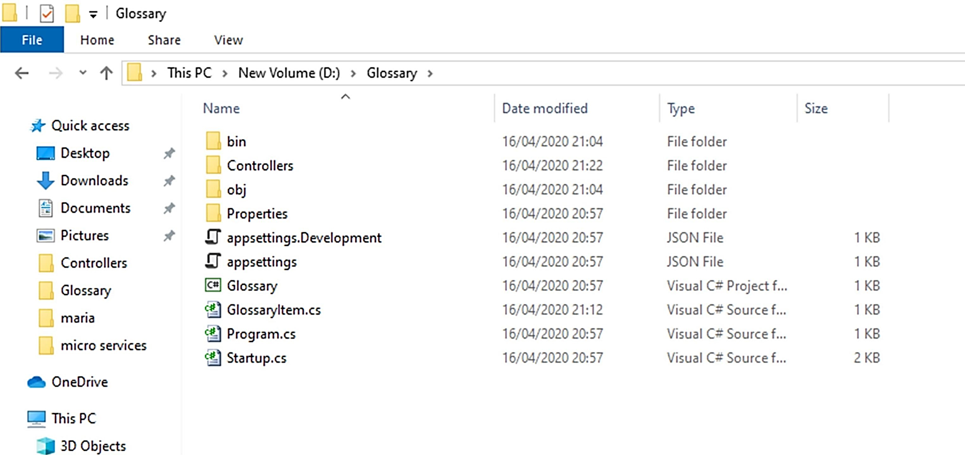

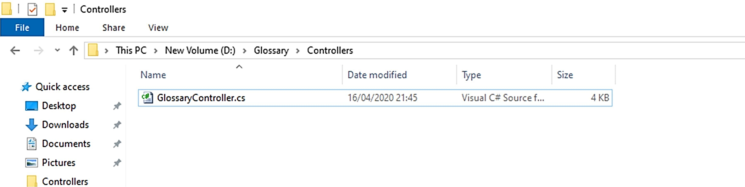

1. **Now stop running previous dotnet run on command prompt 1 using Ctrl+C. and Run it again for new code.**

**On Command prompt1:**

**Command**: dotnet run

**Output:**

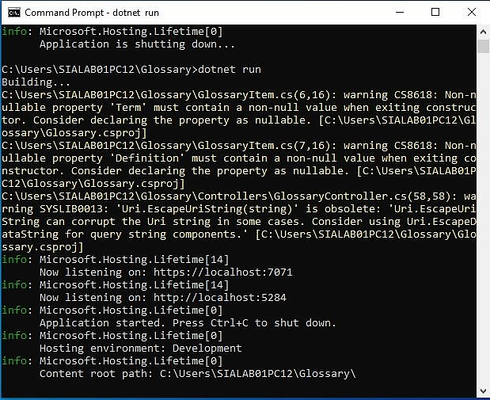

**On Command prompt2:**

1. **Getting a list of items:**

**Command:**

**curl --insecure https://localhost:7071/api/glossary Output:**



1. **Getting a single item**

**Command:**

curl --insecure https://localhost:7071/api/glossary/MVC Output:



1. **Creating an item Command:**

curl --insecure -X POST -d "{\"term\": \"MFA\", \"definition\":\"An authentication process.\"}" -H "ContentType:application/json" https://localhost:7071/api/glossary

**Output:**



1. **Update Item Command:**

curl --insecure -X PUT -d "{\"term\": \"MVC\", \"definition\":\"Modified record of Model View Controller.\"}" -H "Content-Type:application/json" https://localhost:7071/api/glossary **Output:**



1. **Delete Item**

**Command:** curl --insecure --request DELETE --url <https://localhost:7071/api/glossary/openid>

**Output:**



**Practical No. – 3**

**Working with Docker, Docker Commands, Docker Images and Containers**

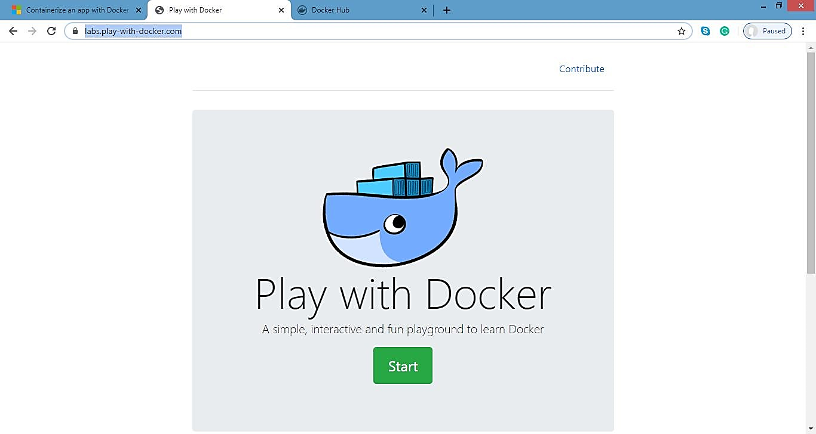

1. Create Docker Hub account (sign up)
2. Login to [https://labs.play-with-Docker.com/](https://labs.play-with-docker.com/)

**Click on start**

1. Add new instance

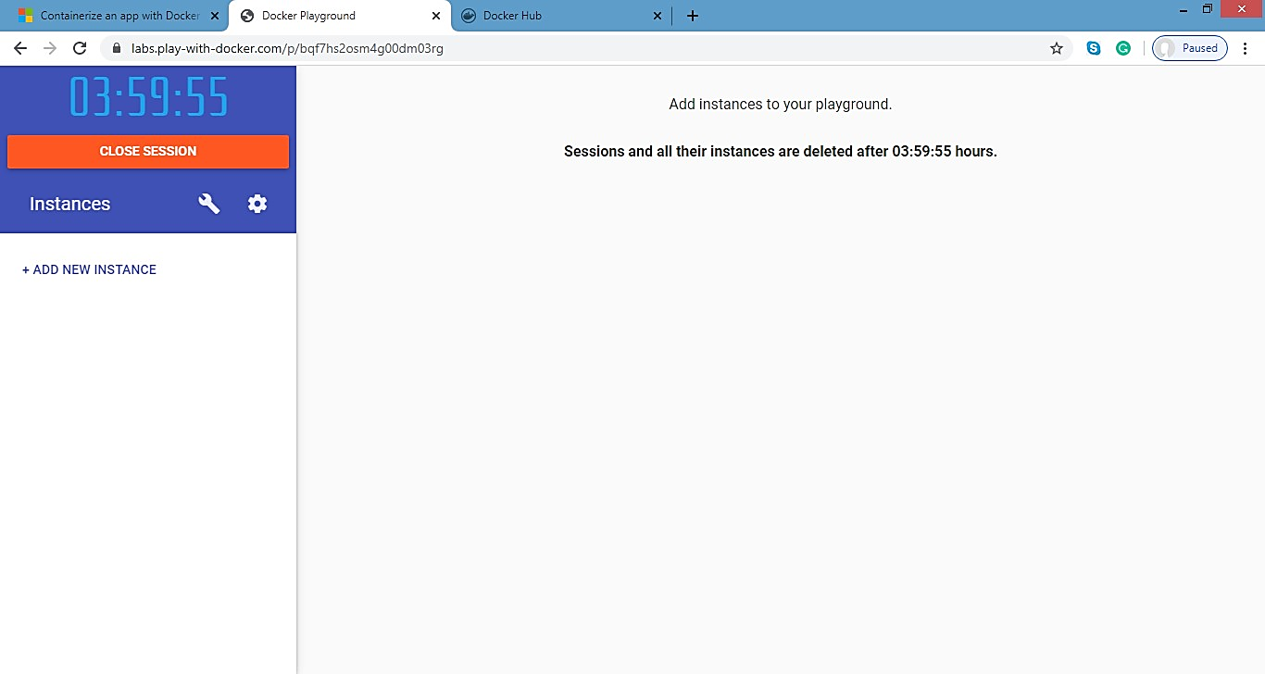

**Perform following:**

**Method1:**

**To pull and push images using Docker**

**Command:** to check Docker version **Docker – version output:**

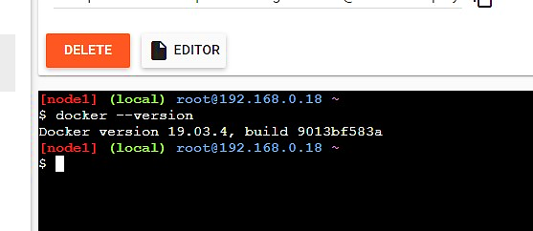

**Command:** To pull readymade image  **Docker pull rocker/verse output:**

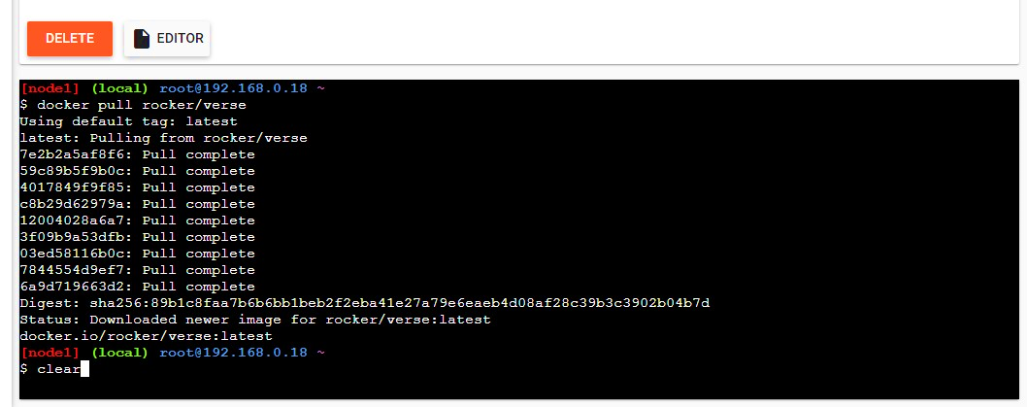

**Command:** To check images in Docker images

**Output:**

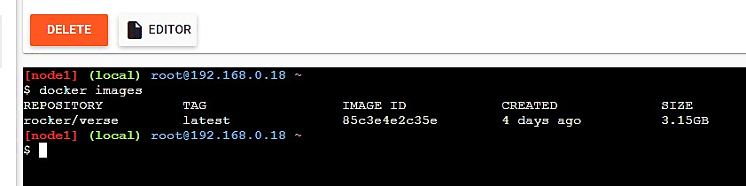

1. Now Login to Docker hub and create repository

**Output:**

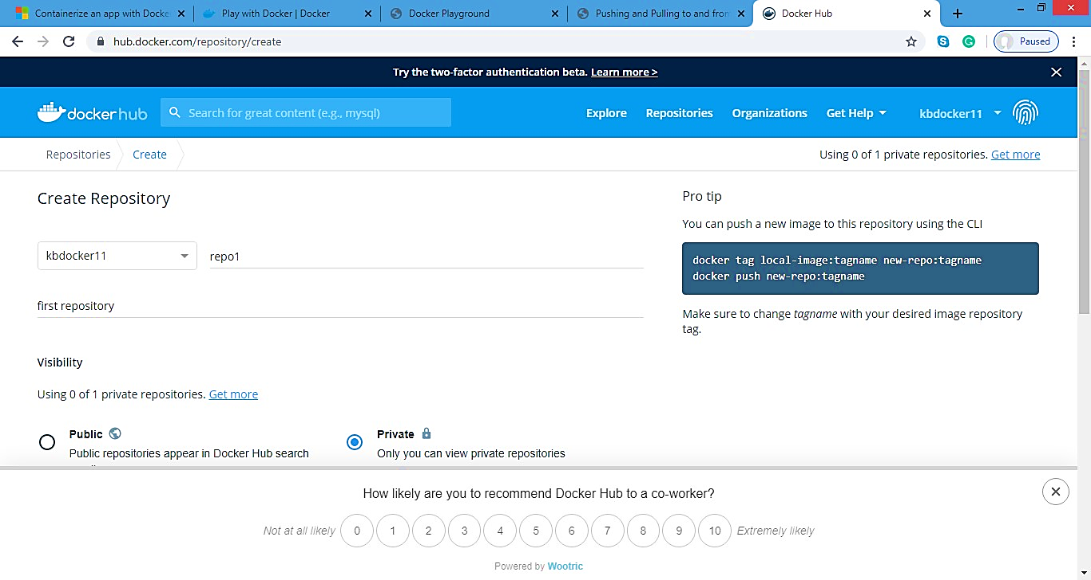

1. Click on Create button
2. Now check repository created

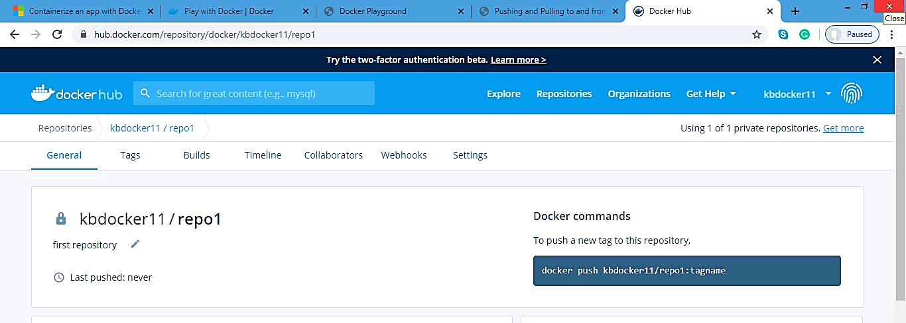

**Command:** to login to your Docker account Docker login –username=kbDocker11

Password:

**Note:** kbDocker11 is my Docker ID. You will use your Docker ID here. And enter your password.

**Output:**

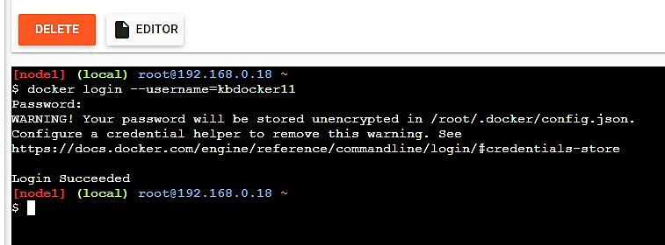

**Command:** To tag image Docker tag 8c3e4e2c3e kbDocker11/repo1:firsttry

**Note:** Here 8c3e4e2c3e this is image id which you can get from Docker images command.

**Output:**

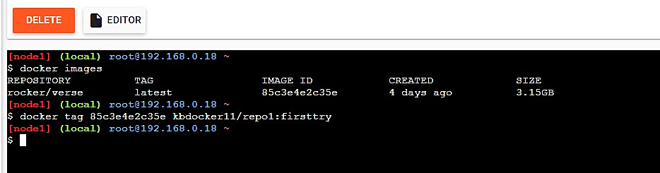

**Command:** To push image to Docker hub account Docker push kbDocker11/repo1:firsttry note: firsttry is tag name created above.

**Output:**

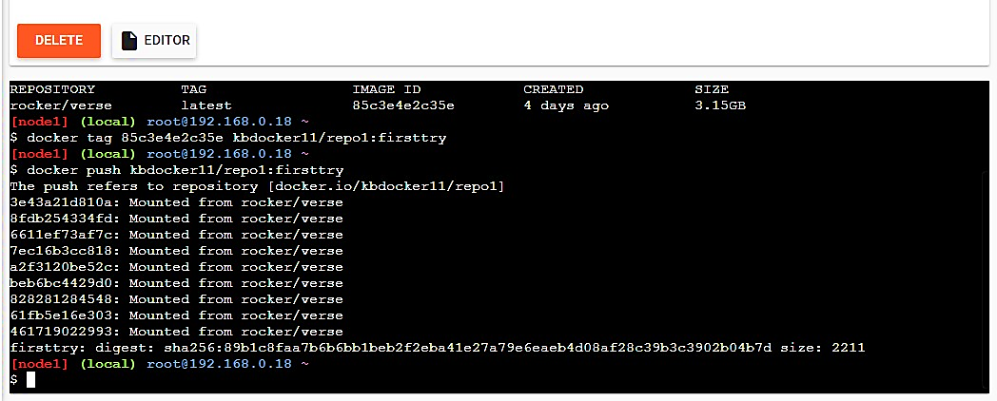

1. Check it in Docker hub now

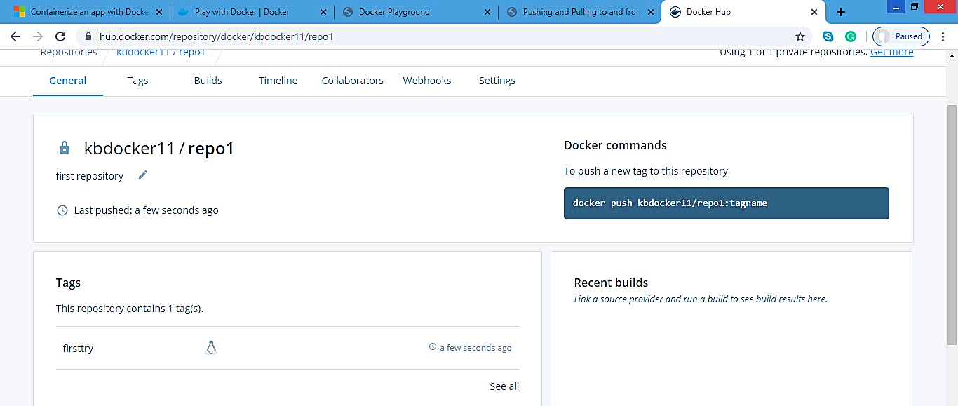

1. Click on tags and check

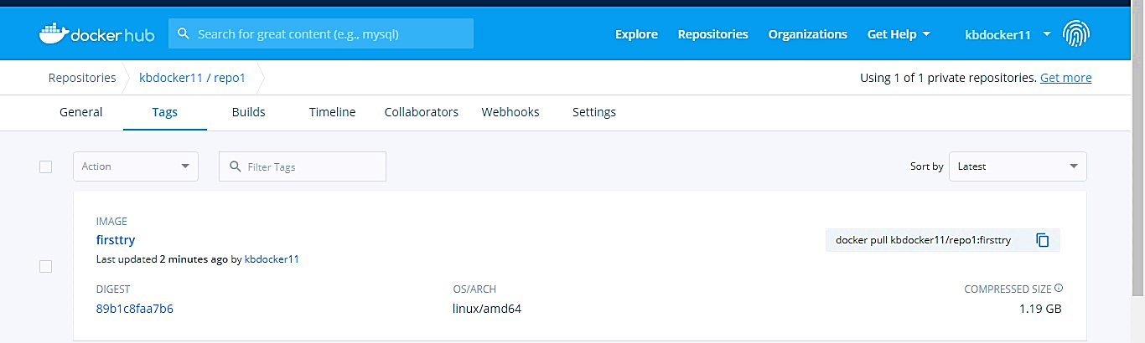

**Method 2:**

**Build an image then push it to Docker and run it**

**Command:** To create Docker file

1. cat > Dockerfile <<EOF
2. FROM busybox
3. CMD echo "Hello world! This is my first Docker image."
4. **EOF Output:**

**Command:** To build image from Docker file

Docker build –t kbDocker11/repo2 .

**Output:**

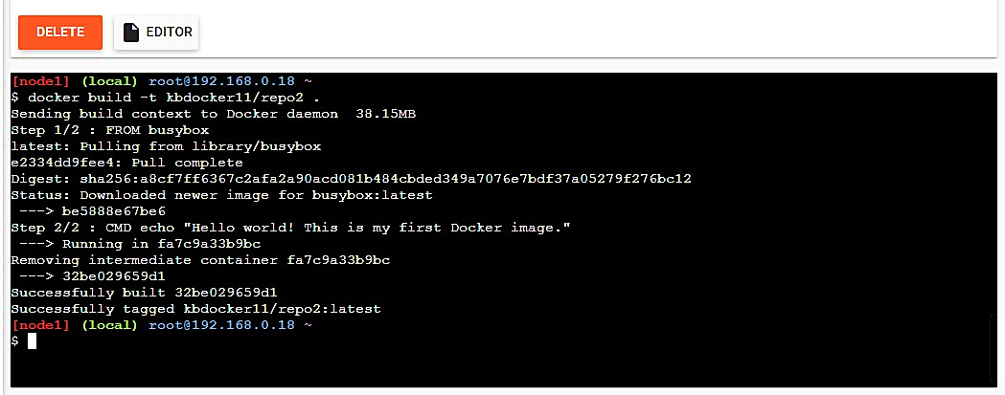

**Command:** To check Docker images Docker images

**Output:**

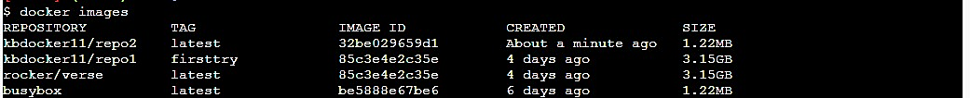

**Command:** To push image to Docker hub

Docker push kbDocker11/repo2 .

**Output:**

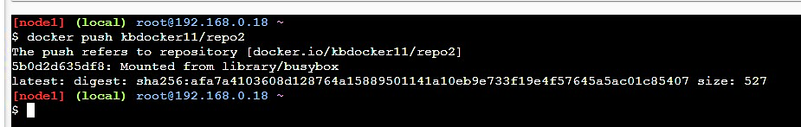

**Now check it on Docker hub**

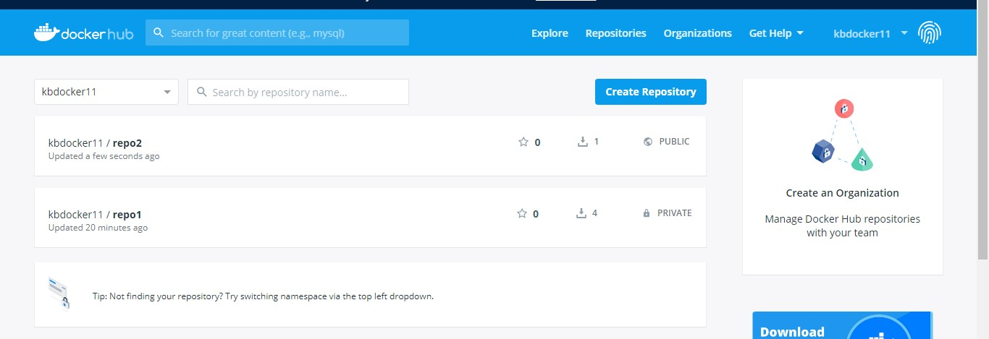

**Command:** To run Docker image:

**Docker run kbDocker11/repo2**

**Output:**

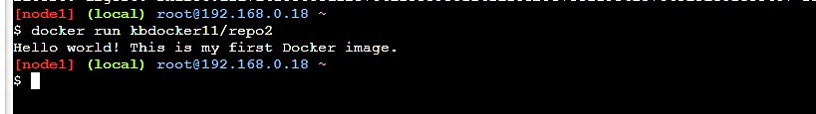

**Now close session.**

**Practical No. – 4**

**Working with Circle CI for continuous integration**

**Step 1 - Create a repository**

1. Log in to GitHub and begin the process to create a new repository.
2. Enter a name for your repository (for example, hello-world).
3. Select the option to initialize the repository with a README file.
4. Finally, click Create repository.
5. There is no need to add any source code for now.

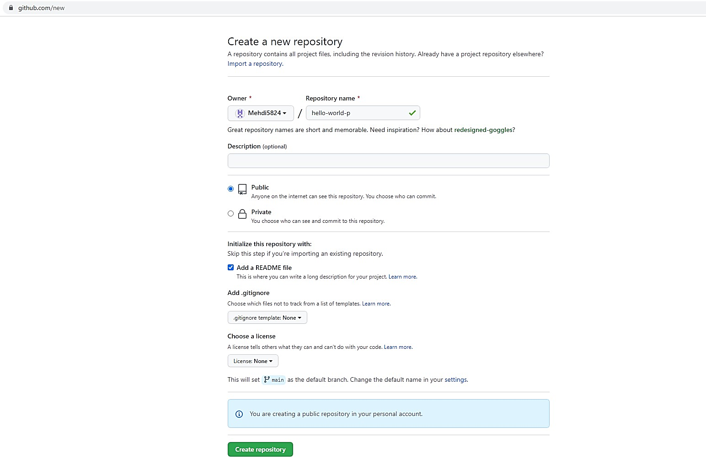

**Login to Circle CI** [**https://app.circleci.com/**](https://app.circleci.com/) **Using GitHub Login, Once logged in navigate to Projects.**

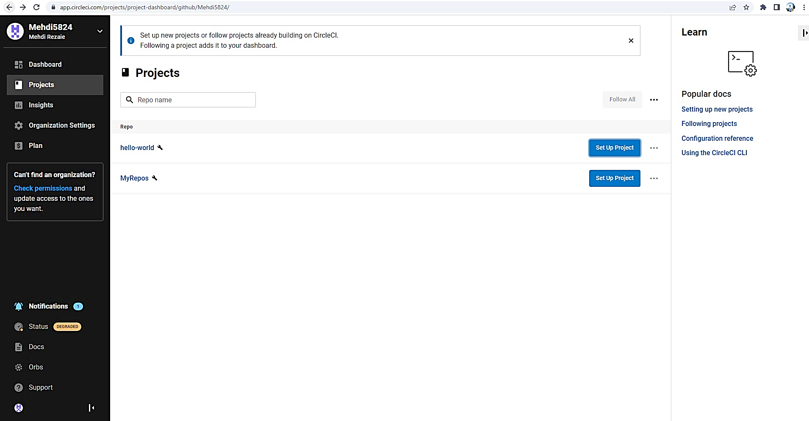

# Step 2 - Set up CircleCI

1. Navigate to the CircleCI Projects page. If you created your new repository under an organization, you will need to select the organization name.
2. You will be taken to the Projects dashboard. On the dashboard, select the project you want to set up (hello-world).
3. Select the option to commit a starter CI pipeline to a new branch, and click Set Up Project. This will create a file .circleci/config.yml at the root of your repository on a new branch called circleci-project-setup.

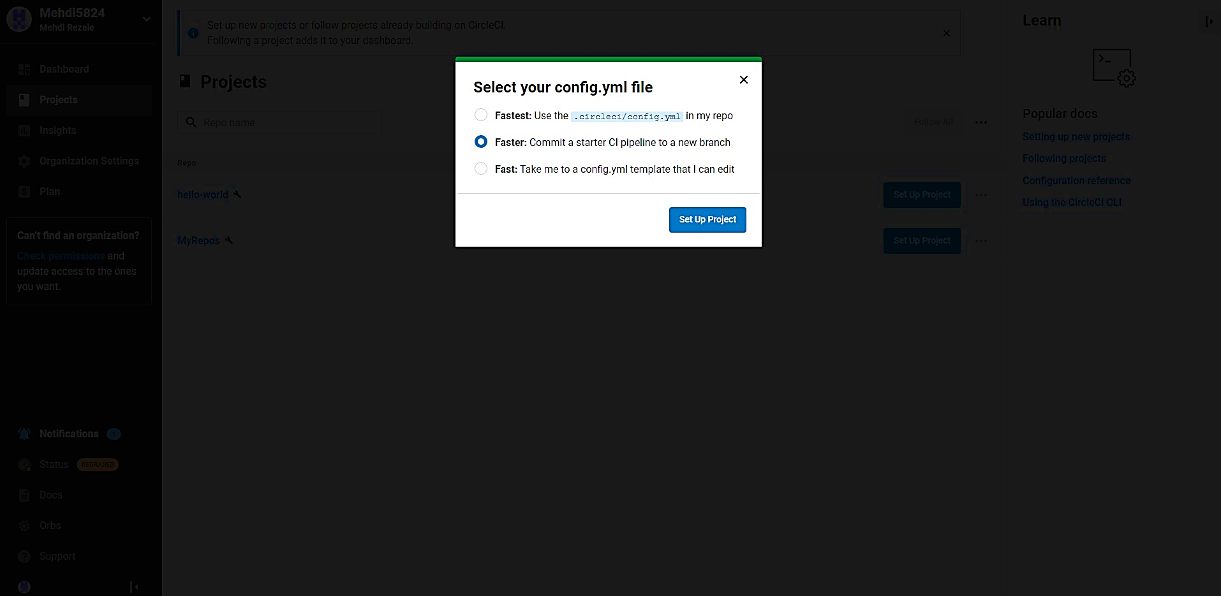

# Step 3 - Your first pipeline

On your project’s pipeline page, click the green Success button, which brings you to the workflow that ran (say-helloworkflow).

Within this workflow, the pipeline ran one job, called say-hello. Click say-hello to see the steps in this job:

1. Spin up environment
2. Preparing environment variables
3. Checkout code
4. Say hello

**Now select the “say-hello-workflow” to the right of Success status column**

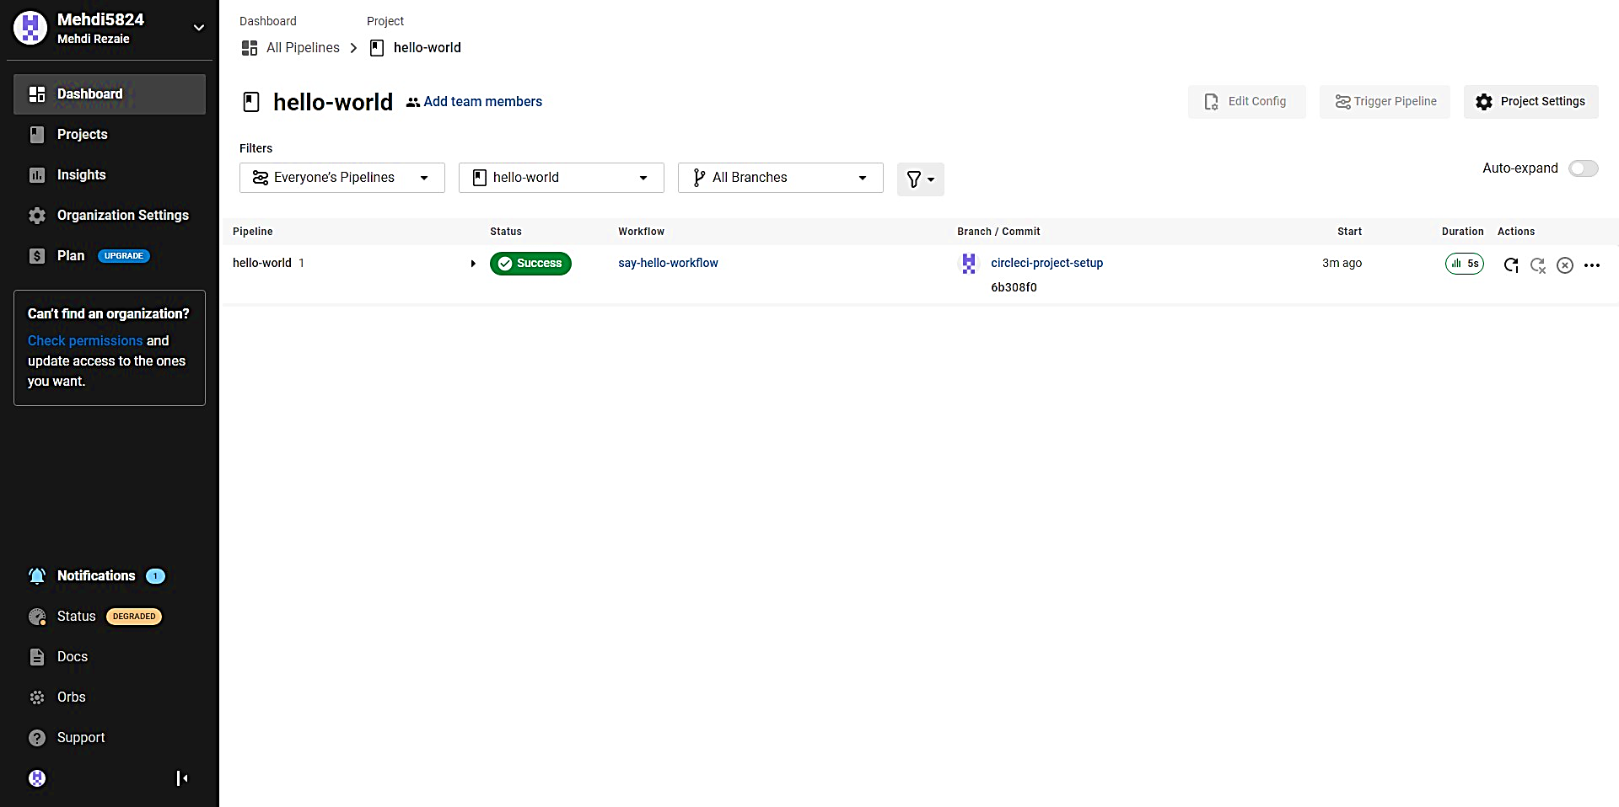

**Select “say-hello” Job with a green tick**

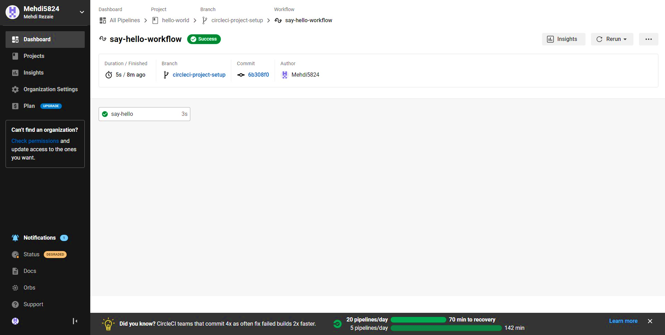

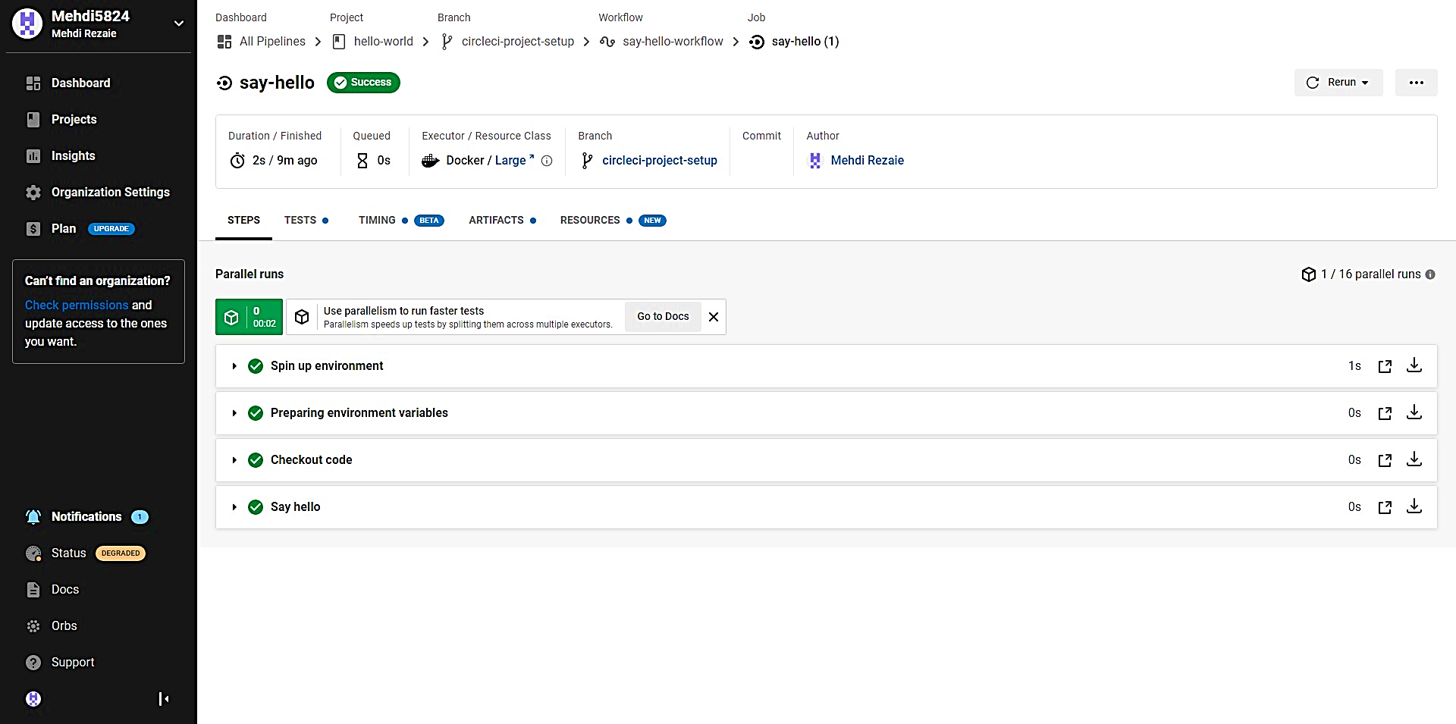

**Select Branch and option circleci-project-setup**

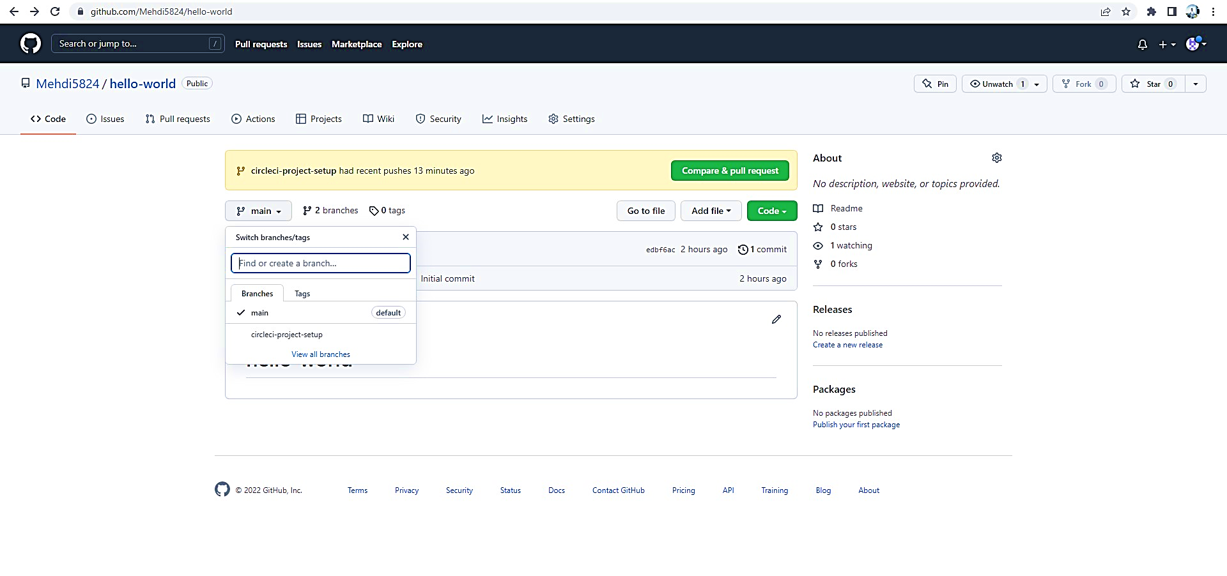

# Step 4 - Break your build

**In this section, you will edit the .circleci/config.yml file and see what happens if a build does not complete successfully.**

**It is possible to edit files directly on GitHub.**

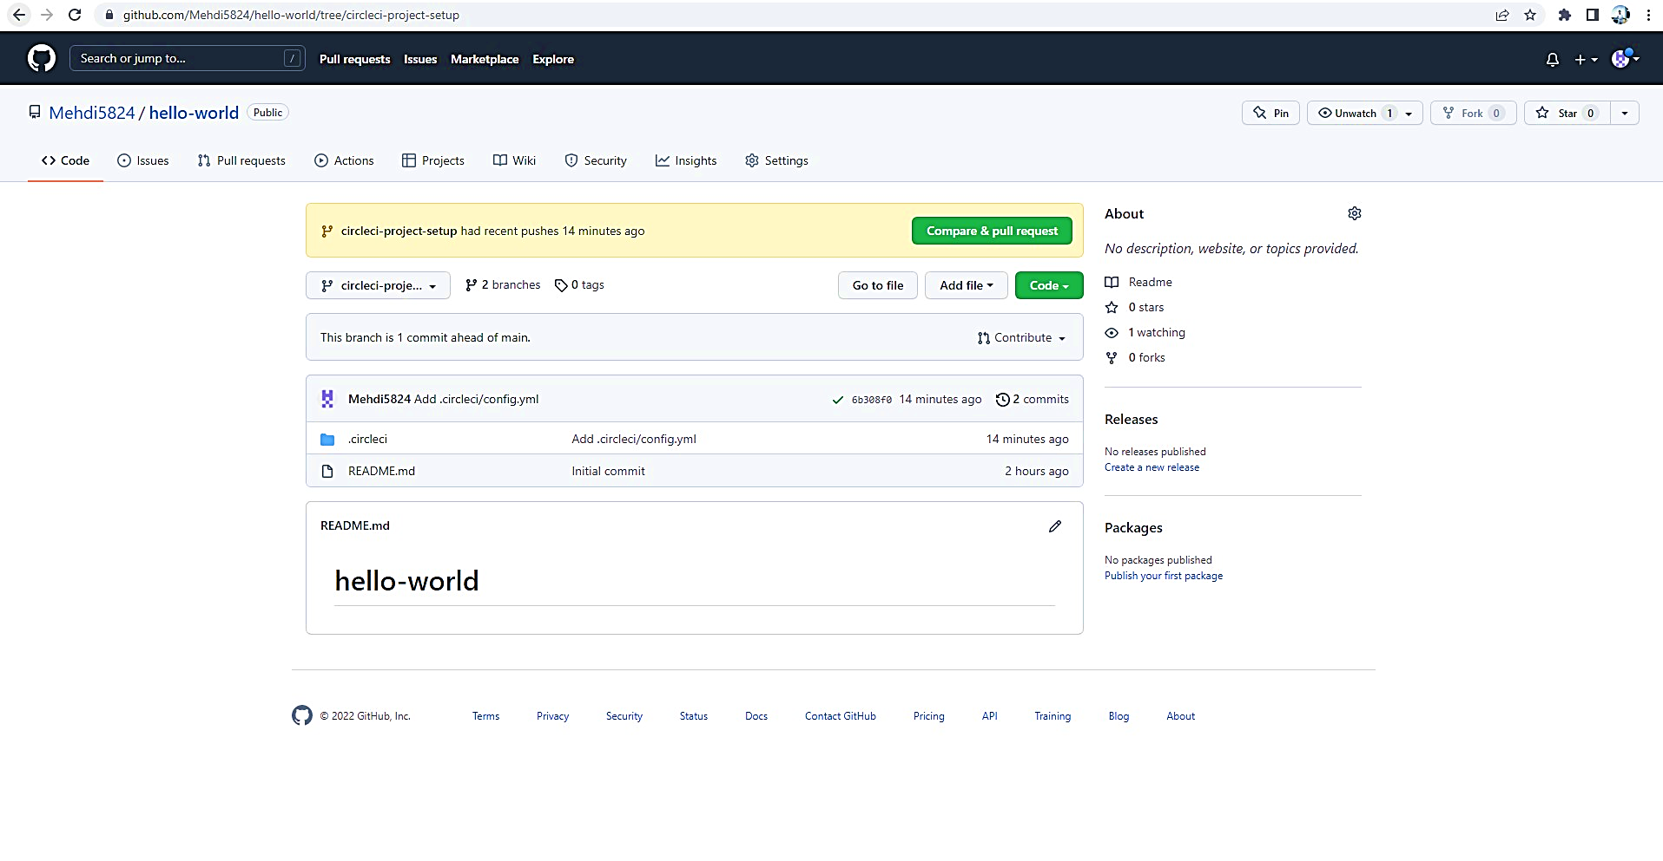

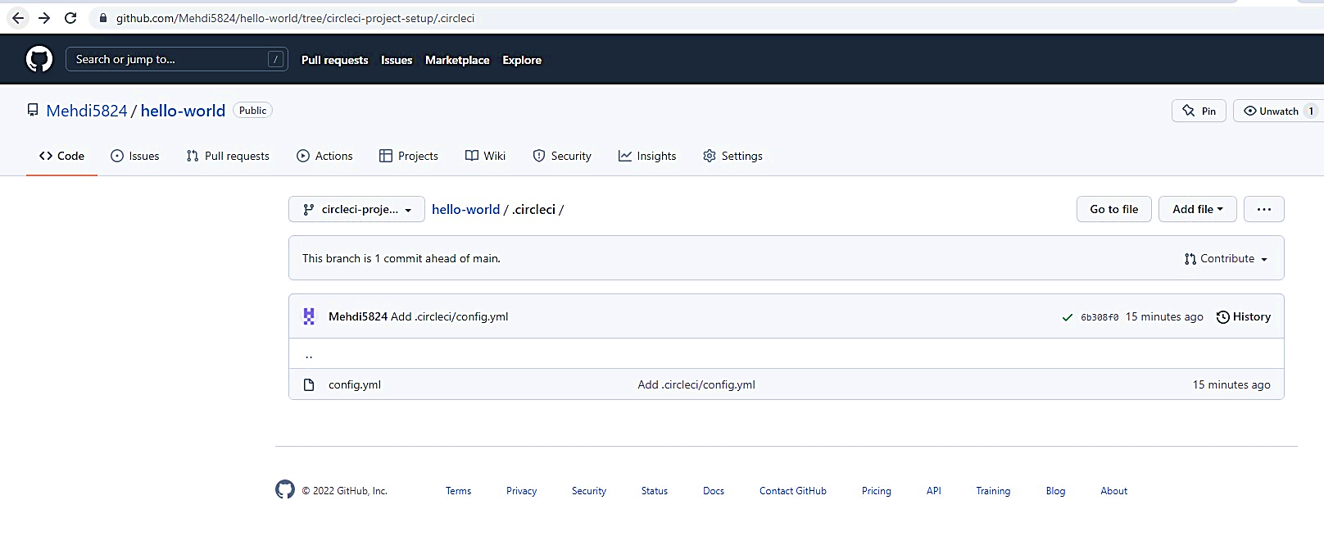

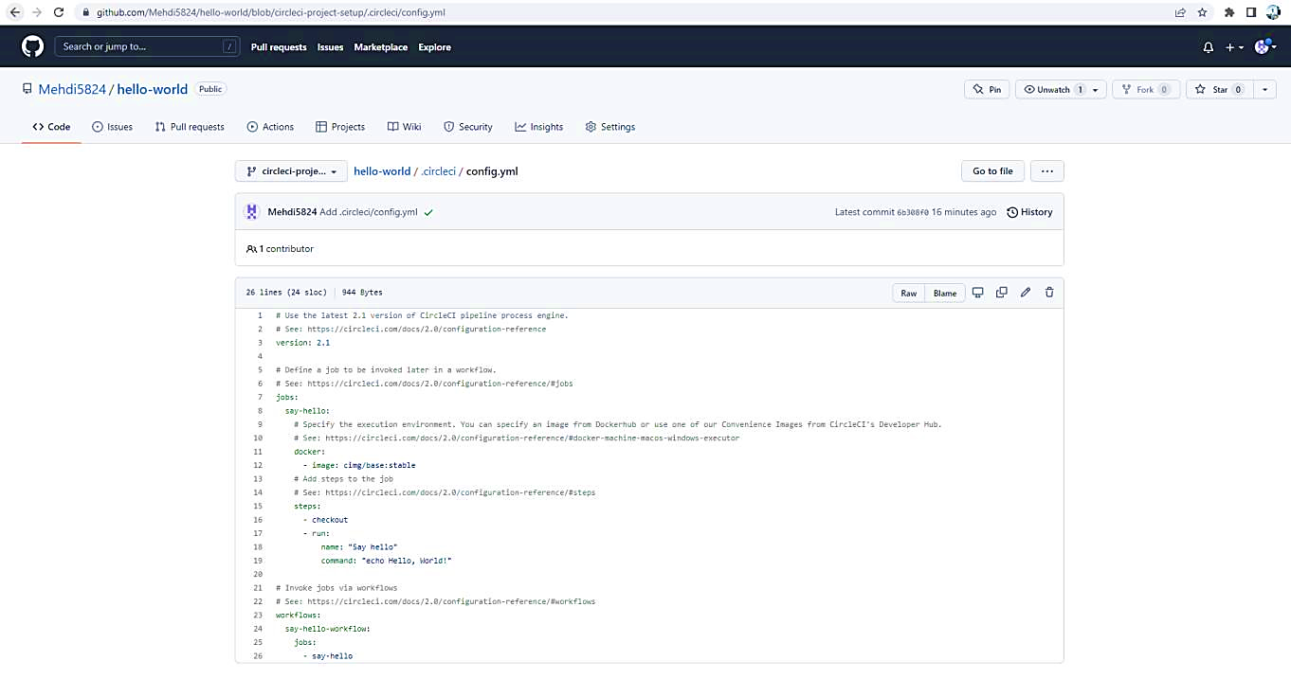

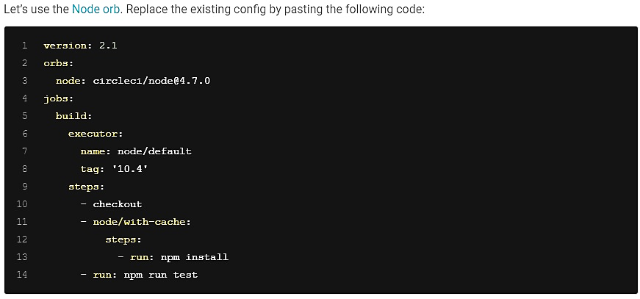

**The GitHub file editor should look like this**

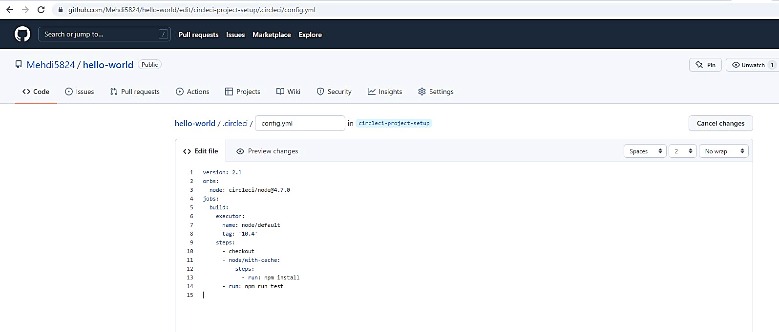

**Scroll down and Commit your changes on GitHub**

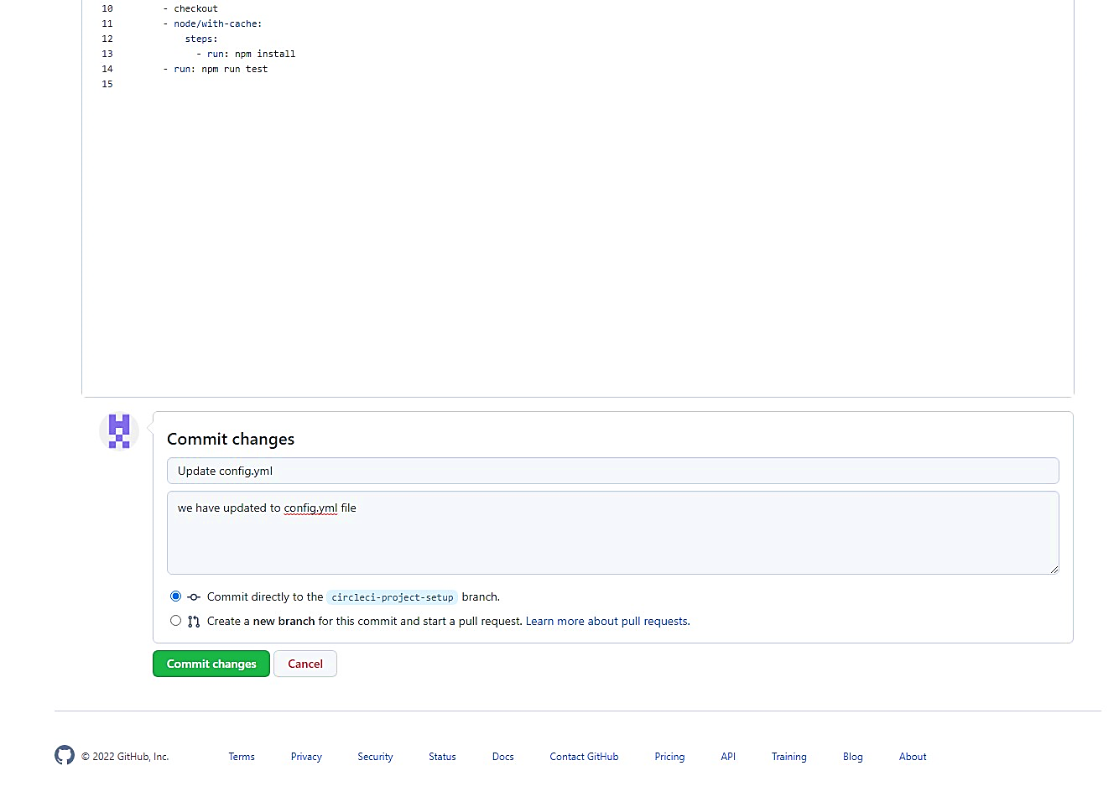

**After committing your changes, then return to the Projects page in CircleCI. You should see a new pipeline running… and it will fail! What’s going on? The Node orb runs some common Node tasks. Because you are working with an empty repository, running npm run test, a Node script, causes the configuration to fail. To fix this, you need to set up a Node project in your repository.**

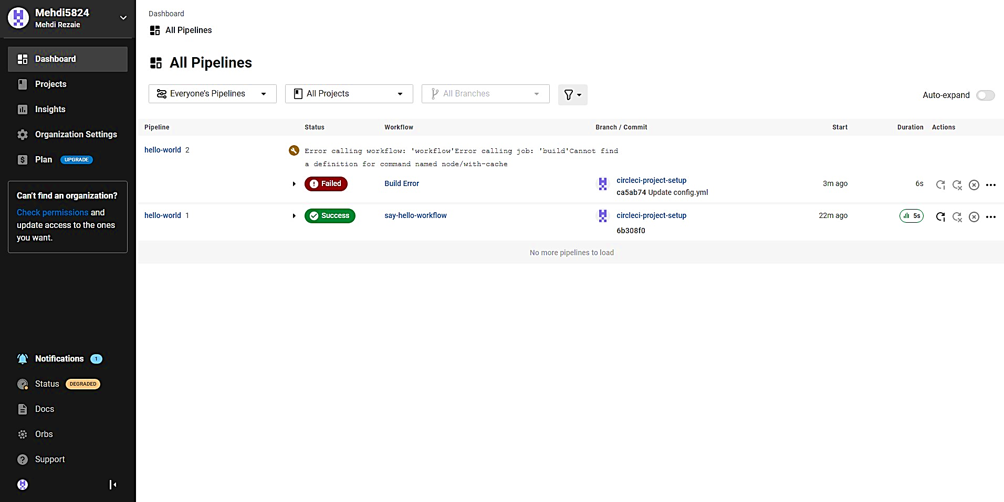

# Step 5 – Use Workflows

**You do not have to use orbs to use CircleCI. The following example details how to create a custom configuration that also uses the** [**workflow feature**](https://circleci.com/docs/2.0/workflows) **of CircleCI.**

1. Take a moment and read the comments in the code block below. Then, to see workflows in action, edit your **.circleci/config.yml file** and copy and paste the following text into it.

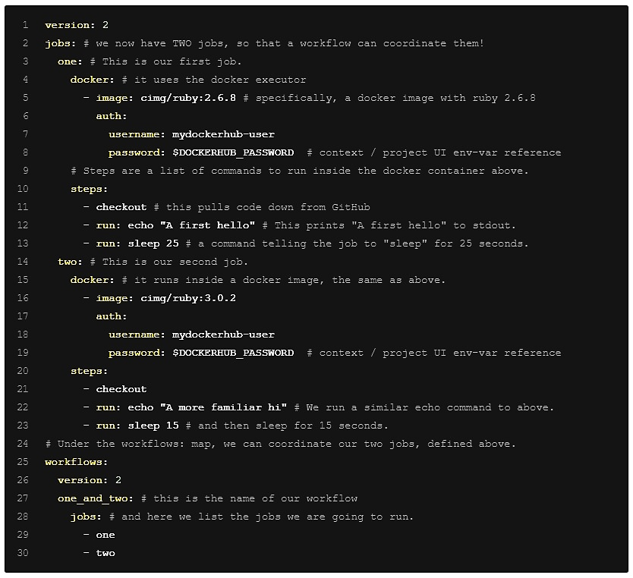

**You don’t need to write the comments which are the text after #**

1. Commit these changes to your repository and navigate back to the CircleCI Pipelines page.

You should see your pipeline running.

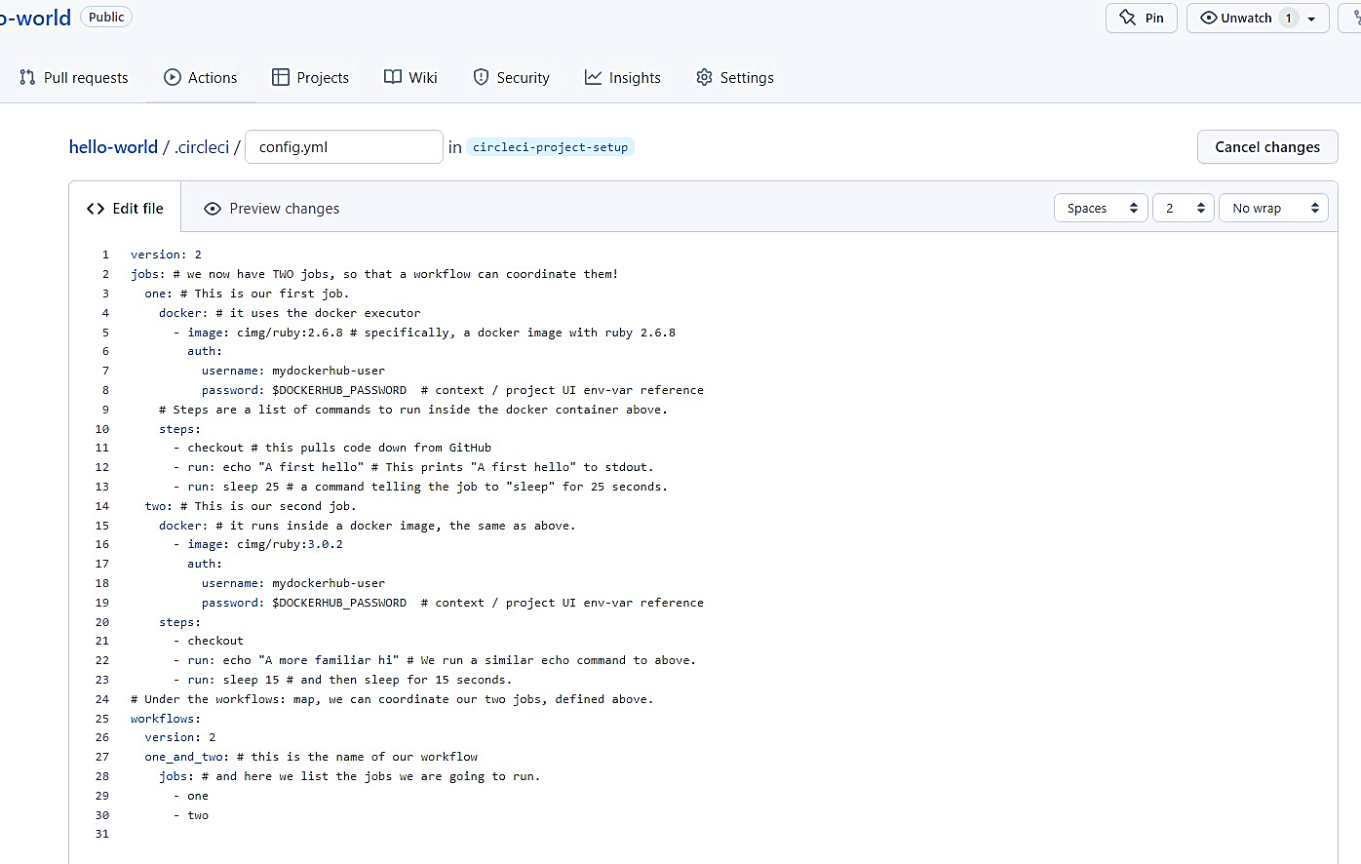

1. Click on the running pipeline to view the workflow you have created. You should see that two jobs ran (or are currently running!) concurrently.

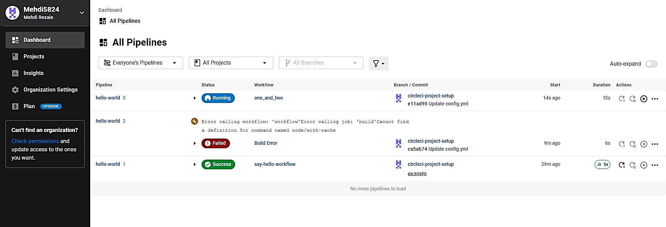

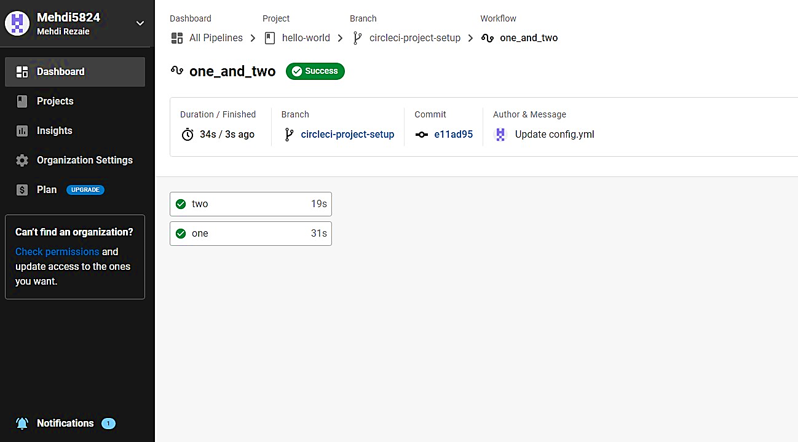

# Step 5 – Add some changes to use workspaces

**Each workflow has an associated workspace which can be used to transfer files to downstream jobs as the workflow progresses. You can use workspaces to pass along data that is unique to this run and which is needed for downstream jobs. Try updating config.yml to the following:**

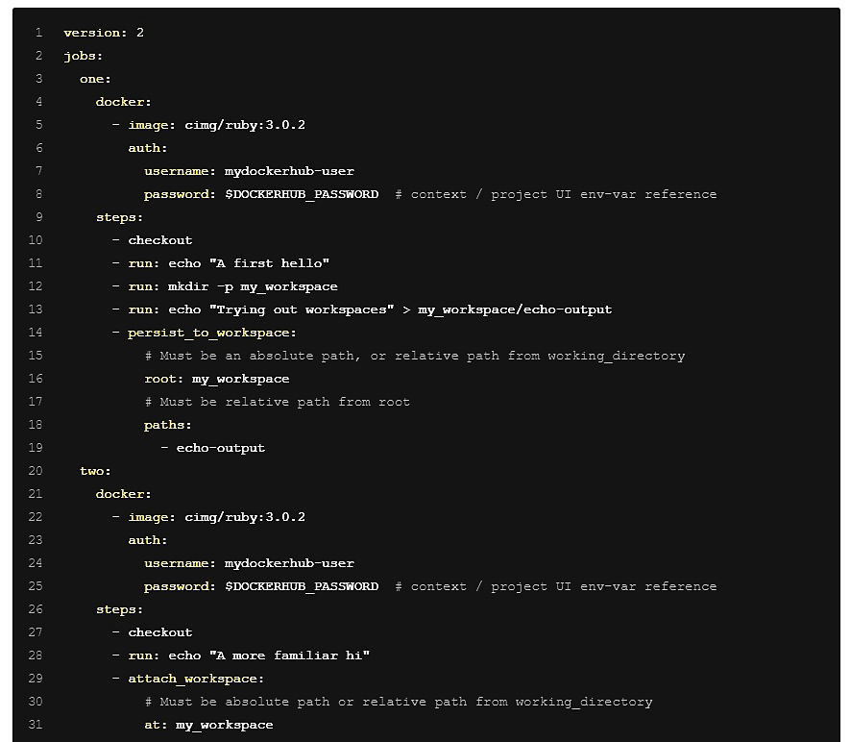

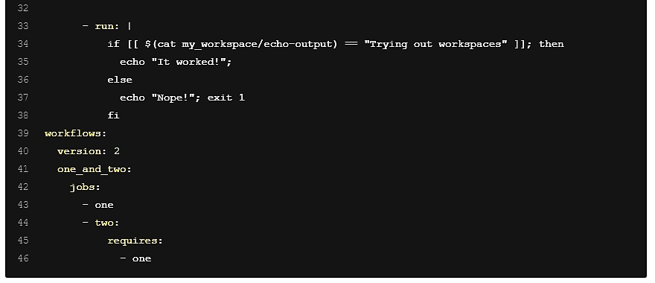

**Updated config.yml in GitHub file editor should be updated like this**

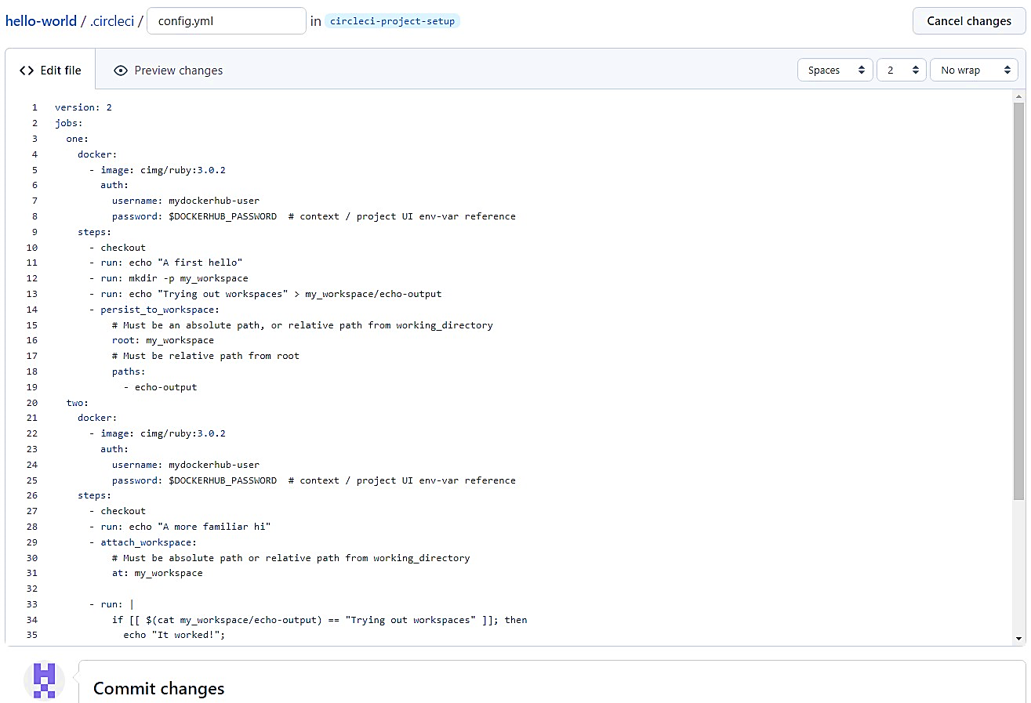

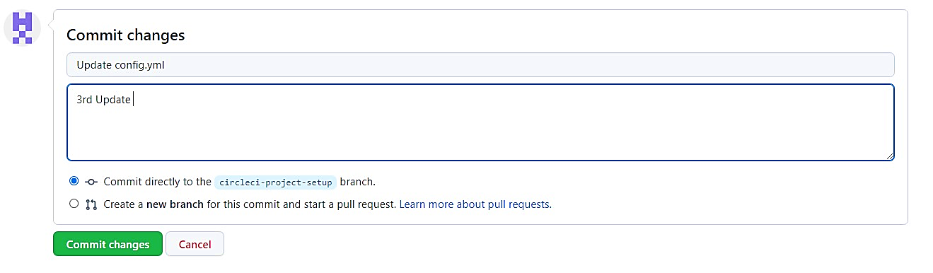

**Finally your workflow with the jobs running should look like this**

